LSM ASSESSMENT 2

19BCI0238

Amaravathi Veerendra nath

SLOT:TAA1

Upload your Work Flow with Time milestone

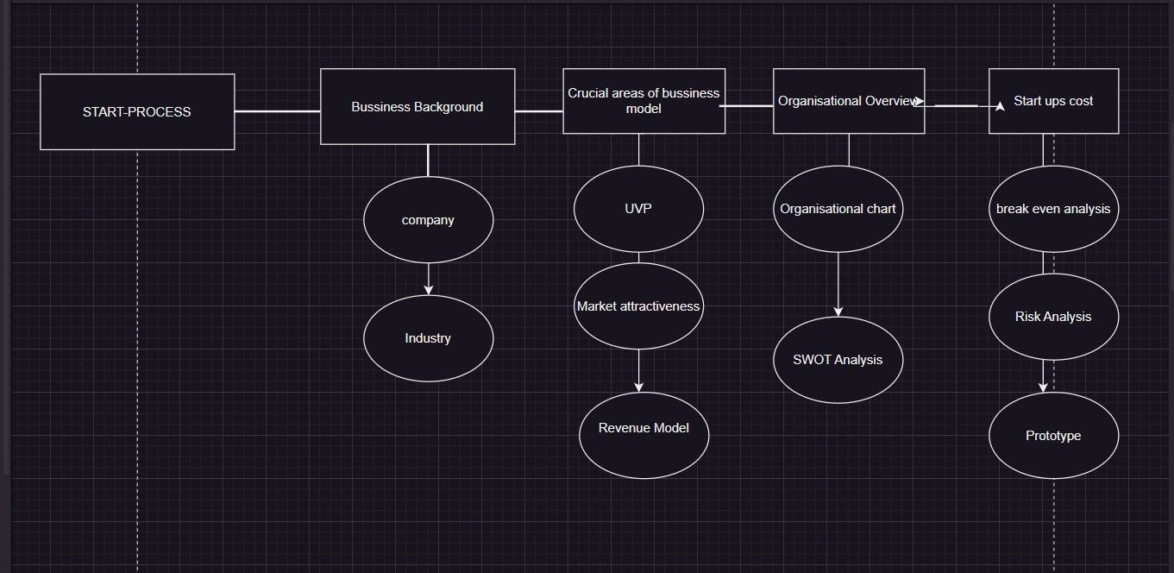

Our business will come under the Electric Vehicle Infrastructure industry. The key to growth of the EV industry is the charging on-the-go model which we are targeting. With companies expanding their EV infrastructure around our country India, there is no proper booking service for EV charging stations. With the government's plan to shift to electric vehicles by 2030, and the plan to achieve net zero emission in future, we are expecting a boom in the number of EV owners hence more customers for ChargeUp and increased profits.

Brand Lot of people who don't want to buy EVs have one common fear of charging their vehicles. To reduce this our brand “Charge Up” makes it easy to find charging stations and book their slots at the time they are free. There are no particular applications which provide these services in India. Our brand makes people move towards electric vehicles.